Ridgecrest 1D velocity model
Developed by Malcolm White

Estimated by Malcolm White by combining and discretizing the models from Lin et al. (2007; 25% weighting), Zhang and Lin (2014; 25% weight) and White et al. (2021; 50% weight).

Z(km) Vp(km/s) Vs(km/s)
- 4.96 2.93
1 5.14 3.01
2 5.45 3.14
4 6.07 3.52
8 6.12 3.62
16 6.24 3.72
32 7.12 4.01
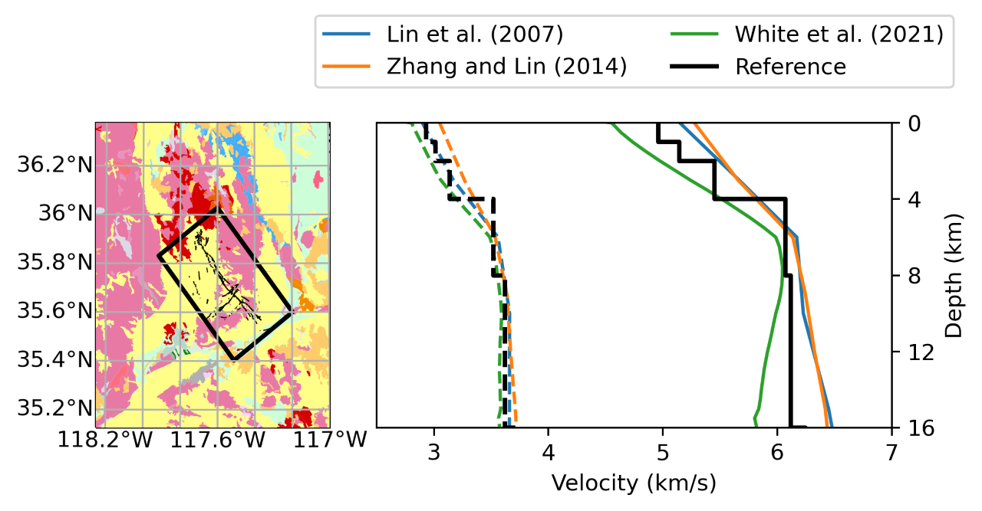
Figure. (left) Geology of the region, with area of applicability in black box. (right) 1D P and S wave velocity model for the region (black curves in right panel), estimated by Malcolm White by combining and discretizing the models from Lin et al. (2007; 25% weighting), Zhang and Lin (2014; 25% weight) and White et al. (2021; 50% weight).

References:
- Lin, G., Shearer, P. M., Hauksson, E., and Thurber, C. H. (2007), A three-dimensional crustal seismic velocity model for southern California from a composite event method, J. Geophys. Res., 112, B11306, doi:10.1029/2007JB004977.
- White, M. C. A., H. Fang, R. D. Catchings, M. R. Goldman, J. H. Steidl and Y. Ben-Zion (2021), Detailed traveltime tomography and seismicity around the 2019 Mw 7.1 Ridgecrest, California, earthquake using dense rapid-response seismic data, Journ. Geophys. Int’l, in press.
- Zhang, Q. and Lin, G. (2014). Three-dimensional Vp and Vp/Vs models in the Coso geothermal area, California: Seismic characterization of the magmatic system. J. Geophys. Res., 119(6):4907–4922.

